Jeziel E. Torres Vázquez

INEL 4998 (Research)

Prof. Eduardo Ortiz

Week: February 22-26

The past week I was tasked to investigate and study about what monitors where and how we could use them in OpenDss. This will help us with the analysis part of the research. With all this knowledge we could justify and analyze better why the components and parameters are the better ones for our system. For this I started by searching on google about monitors in OpenDss. There were tons of questions of people asking how to use them and how to write the code for them. I read most of the questions; this is because not every question was important for the task. I learn a lot from all the stuff I search, from writing code to explain what the mode meant and on what it could be used.

Another task that was given to me was to investigate specifically mode “0” of monitors. This mode is for voltage and current graph and plots. This graph shows how the voltage and current behaviors through time. Here is the voltage graph that OpenDss plots when the monitor is connected to one of the PV systems the Design Team created last semester. This Voltage graph is specifically from the PV system from the Science building

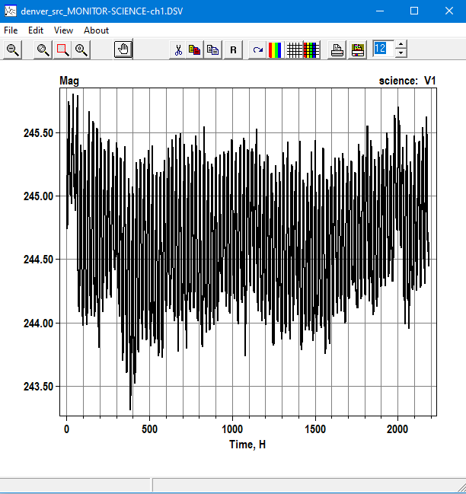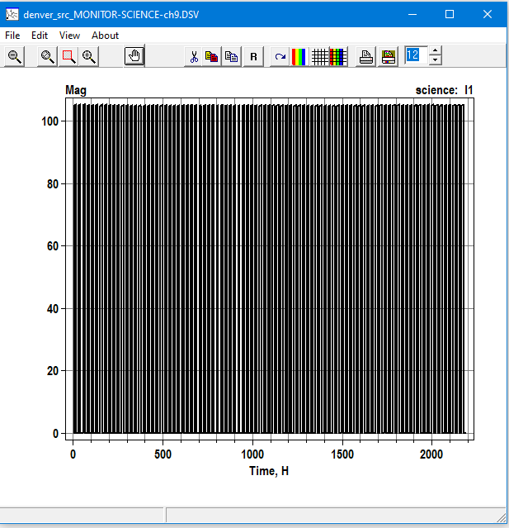

Graph 1: Science Building Voltage vs Time Graph 1: Science Building Current vs Time

In Graph 1 we can see how the voltage behaves through the daytime of an entire year. This is because OpenDss is programmed to give the result in intervals of 15 minutes in the daytime. The voltage of the PV system of the Science Building is almost identical through the year, but there are some moments where the voltage drops quite a few compared to all the year. In Graph 2 we can see some weird stuff happening. This is because the current the PV is sending is DC and because of that the current goes up and when there is no sun it drops. This plot is of 15 minutes intervals and for a whole year. In my search for more information about the modes I stumble with 2 articles that talk about OpenDss. One of them is a CheatSheet that has almost everything on how to code and what the parameters mean. The other one is a complete guide on how to use OpenDss, with example and explanation of the code and parameters. Both documents are from the University of Chile

